Students who demonstrate understanding can:
Standard(s): EX: HS-LS3-1. Ask questions to clarify relationships about the role of DNA and chromosomes in coding the instructions for characteristic traits passed from parents to offspring. *CAUSE AND EFFECT [Clarification Statement: Emphasis should be on the distinction between coding and non-coding regions of DNA.]
Phenomena/Topic: What is in DNA that makes you who you are? (example)
ENGAGE: Capture student interest
-Display a picture, primary source, news article, visual aid.
-Short video clip (1-5min)
-Simple Demonstration
-Revisit Information learned previously.
-Reflection on quote or analogy

I notice…(observation) | I wonder…(questions)

Put a star next to your priority question/write on a post it/add to question board
Class Essential Question:

__________________________________________________________________________________________________________________________________

Initial Student Model:
Complete the initial model with a drawing and writing.
Examples and templates can be found here: Graphics and Tools — The Wonder of Science
- Cause and Effect Cause+Effect+-+Small.pdf (squarespace.com) or Cause+Effect.pdf (squarespace.com)
- Patterns Patterns.pdf (squarespace.com)
- System and System Models Systems.pdf (squarespace.com)
- Structure and Function Structure+Function.pdf (squarespace.com)
- Scale, Proportion, Quantity Scale+Proportion+Quantity.pdf (squarespace.com)
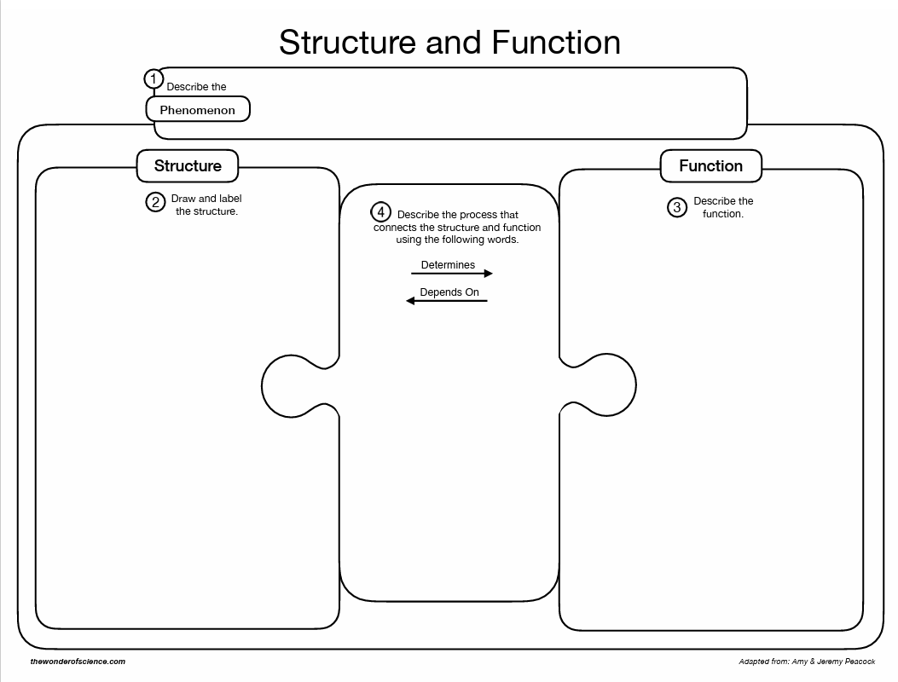
- Check out website for more!

Explore: (Students work together in cooperative learning task)
- Hands-on
- Simulation
- Mini-Activity
- Demo
- Lab investigation

Explain: (Formal introduction of important terms and vocabulary)
- Vocabulary organizer
- PowerPoint
- Notes
- Foldables
- Explanatory Video with worksheet

Elaborate: (Students extend their understanding of new concept by using and applying the knowledge to an activity)
- Problem solving task.
- Investigation
- Real-world task/connection
- Independent Practice (no simple basic worksheets, make high level thinking mixed with NYSSLS assessment questions)
- Game
- Station activity to practice skill/concept in a variety of ways.
*You can show another phenomena/concept and cycle back to EXPLORE, EXPLAIN

Revise Original Model/ Final Model
(insert same template as initial model here)

In the final model be sure to include:
-
-
-

Explain your model in 2-3 sentences: _________________________________________________________________________________________________________________________________________________________________________________________________________________________________________________________________________________________________________________________________________________________________________________________________

Evaluate: Students demonstrate they have achieved the objectives and are assessed (formative or summative)
- Use the final model and explanation.
- Traditional worksheet
- Quiz/Exam
- Exit ticket.
- Lab report
- Problem solving/critical thinking task.
- CER (templates attached)

CER Example Templates

- Construct an explanation based on evidence/ information obtained from class activity that answer the following question:

Claim
Make a claim that answers the question.
Evidence
Describe specific evidence from the models, images and investigations provided on the preceding pages.
Reasoning
Describe a chain of reasoning that connects the evidence described to your claim.

CER Question: __________________________________
Directions: Complete the CER framework below and then compile it all into a paragraph. *Make sure to utilize the checklist
By answering the question, you made a CLAIM about the situation.
Evidence Checklist:
❏ Is each piece of evidence relevant to the claim?
❏ Is there enough evidence to sufficiently support the claim?
❏ None of the evidence includes information that does not support the claim.
❏ Does the evidence lack an explanation or reasoning?
Evidence:
Claim Checklist:
❏ Does the claim answer the question?
❏ Does the claim lack an explanation or reasoning?
❏ Is the claim written in a complete sentence?
❏ Is the claim more than a "yes" or "no" answer?
Claim:
*What evidence do you have based on the provided information?

Reasoning Checklist:
❏ Is there justification of how each piece of evidence supports the claim?
❏ Is there a link between the evidence and your claim? (Remember, the reasoning should not simply repeat the evidence)
❏ Is the reasoning written in complete sentences?
Reasoning:
*How and why does your evidence support the claim you made?

Now, put it all together. Construct a 5-7 sentence paragraph explaining what happened. Restate your claim, provide your evidence and reasonings to make connections as to how, and why, your evidence supports your claim.
CER Argument → ?

